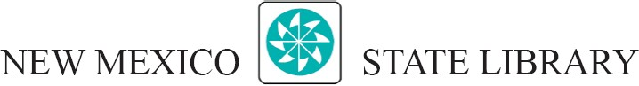

Minutes

New Mexico State Library Commission Meeting

May 2, 2025, 1PM
New Mexico State Library, Commission Room, 1209 Camino Carlos Rey and by Zoom
In attendance: Chair Dean Smith (by Zoom), Heather Cameron, Elizabeth Martinez; State Librarian Eli Guinnee
Absent: Cynthia Shetter, Michael Taylor
- Call to order
Meeting was called to order by Chair Smith at 1:05pm.
- Approval of agenda
Motion for approval of Agenda.
First: Cameron; Second: Martinez; Passes
- Approval of minutes of February 28, 2025 meeting
Motion for approval of Minutes.
First: Cameron; Second: Martinez; Passes
- State Library Report
State Librarian Eli Guinnee presented the 2025 3rd Quarter Report, focusing on Federal Funding issues and Rural Library grants. LSTA fund outlook continues to change rapidly, the State Library currently has access to LSTA 2024 funds and half of LSTA 2025 funds. Rural Libraries will receive grants of $43,000 in one time grants and $23,000 in regular Rural Libraries grants.
- Public Comment
None.
- Next meeting date(s) and location
The next meeting is scheduled for October 3 at 1pm in the NMSL Commission Room and by Zoom. The Annual Conference Meeting will fall on October 24 at 11am at the Marriot Pyramid, Albuquerque.
- Adjournment
Motion to adjourn at 2:30pm.
First: Cameron; Second: Martinez; Passes

