NEW MEXICO HISTORY IN 10 MINUTES!
Watch State Historian Rob Martínez talk about
New Mexico history in 10 minutes in 70 episodes!
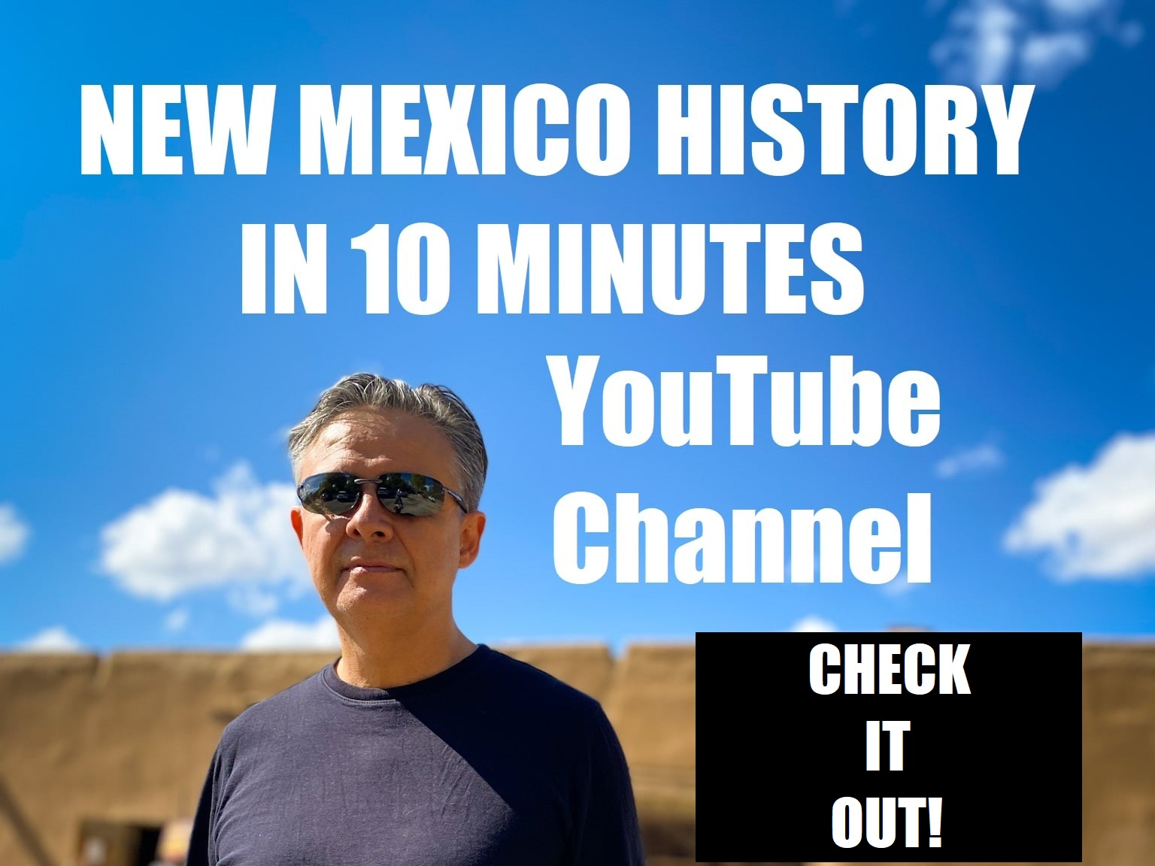
Click HERE to watch all 70 episodes:
https://www.youtube.com/channel/UCAYZRD5lEaxtUgaBVdc4R6Q/videos
FOR MORE INFORMATION: 505-476-7911 email: rob.martinez@state.nm.us
