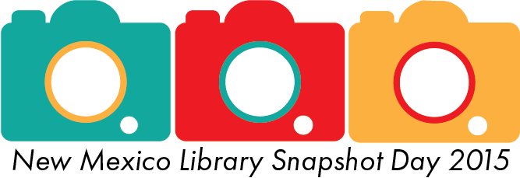
FOR IMMEDIATE RELEASE
APRIL 13, 2015
<<YOUR LIBRARY>> TO HELP CAPTURE PICTURE OF NEW MEXICO LIBRARIES ON APRIL 16
<<YOUR LIBRARY>> will participate in a statewide library advocacy event on Thursday, April 16: New Mexico Library Snapshot Day 2015. Administered by the New Mexico State Library, the goal of Snapshot Day is to demonstrate the impact library services have on the state by tracking participation in library programs and services rendered on a single day.
Participating libraries will also gather photos from their libraries, which will be compiled by the State Library to create a comprehensive picture of a day in the life of New Mexico Libraries.
“Snapshot Day has been a successful advocacy project across the country for the past few years, and we are excited to get New Mexico involved again,” Acting State Librarian and Department of Cultural Affairs Deputy Secretary Michael Delello said. “It’s an excellent way for New Mexico libraries to come together and promote the vital services they provide in their communities each day. By sharing data, photos, and stories about their libraries, they can really impact decision makers in their communities.”
“QUOTE” YOUR LIBRARY DIRECTOR said.
<<List any specific information you would like to release to the press here including any special events you have going on during Snapshot Day.>>

###
Media Contact:
Your information here: Name, email address & phone number where reporters can reach you

